**Task No. 1.1:** On Cisco switches, where is the running configuration loaded from?

**Solution:**

The running configuration is stored in RAM on a Cisco router.

**Task No. 1.2:** What does the flash memory on a switches store?

**Solution:**

Flash memory is an Electronically Erasable and Re-Programmable memory chip.  It is used to store the Cisco IOS that runs on your router. It contains the IOS that will be running on the router which helps in upgrading the OS without any chips to be removed.

**Task No. 1.3:** When you are logged into a switch, which prompt indicates that you are in

privileged mode?

**Solution:**

**“#”** indicates that we are in privileged mode.

**Task No. 1.4:** On which modes in Cisco's IOS you can issue show commands?

**Solution:**

In Cisco’s IOS, we can issue show commands in privileged mode.

**Task No. 2:** Create two users Admin_'yourfirstname' and Admin_'yourlastname' grant all privileges to them then login by using Admin_'yourfirstname' then remove (Admin_'yourlastname'). Clearly show command for every step.

**Solution:**

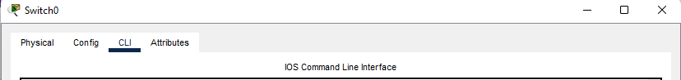

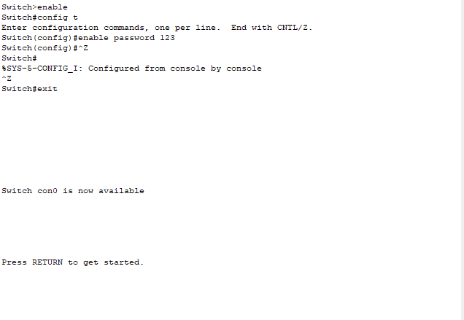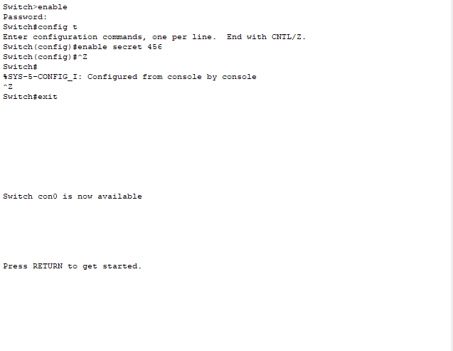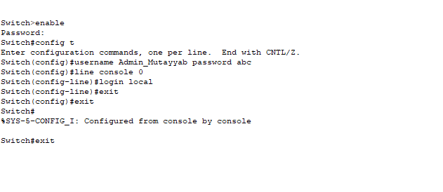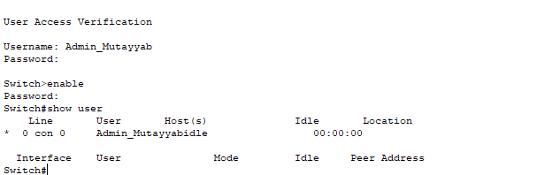



Admin_Ahsan



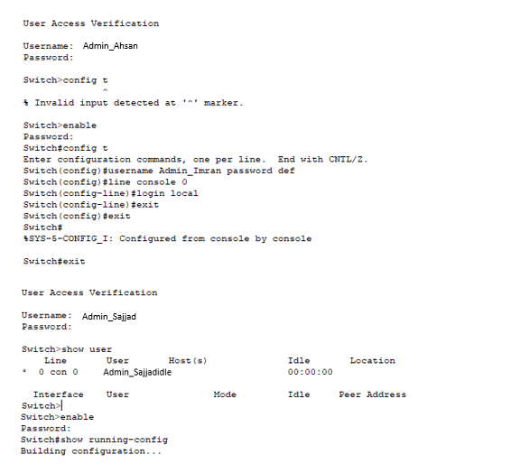

**Task No. 3:** Show the encrypted console password, Privilege mode passwords and all user’s passwords.

**Solution:**

**BEFORE ENCRYPTION**

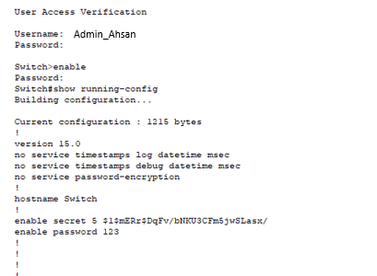

**AFTER ENCRYPTION**

**Banner MOTD**

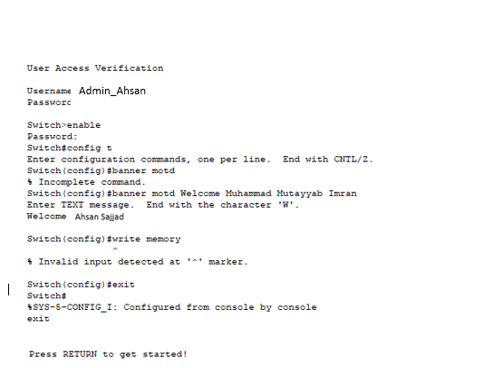

**Set Clock**

